Comp 1004 - 24/10/23

<https://www.visual-paradigm.com/guide/uml-unified-modeling-language/uml-class-diagram-tutorial/>

Classes vs Objects

The base class is the general overarching structure that objects build themselves from. For example: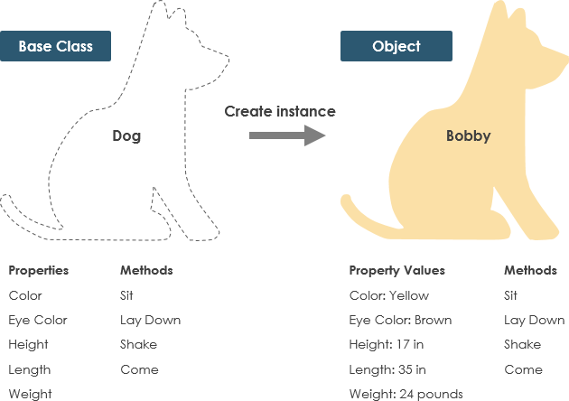

UML Diagrams

Can be used to model:

* Software solutions
* Application structures
* System Behaviour
* Business Processes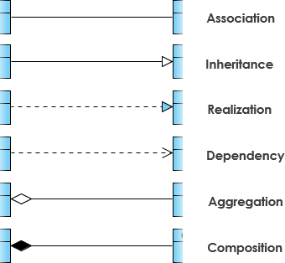

Relationships between classes are represented using:

Class attributes are represented using: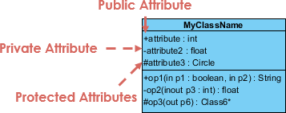

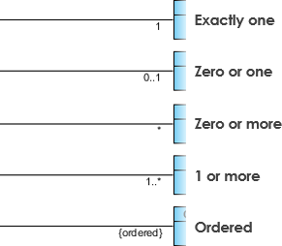

# Cardinality

Cardinality is the numerical relationship between rows of one table and another. Common types include one-to-one, one-to-many, and many-to-many. Cardinality can be used to define data models as well as analyse data within tables.